TABLE OF CONTENTS
Abbreviation and Acronyms iv
Message from District Commissioner v
Message from Chair Person vii
Foreword viii
Vision of the Council ix
Mission Statement ix
Guiding principles ix
Investment Overview x
CHAPTER ONE 1
1.0 Introduction 1
1.2 Land Area and Land Use 1
1.3 Topography and Drainage 2
1.4 Climate, Soils and Vegetation 2
1.5 Agro-Ecological Zones 3
1.6 Administrative Units 3
1.7 Population Size and Growth 3
1.8 Economic Development 4
CHAPTER TWO 5
MAJOR ECONOMIC SECTORS 5
2.1 Agriculture and Livestock 5
2.1.3 Investment Opportunities in Agriculture Sector 6
2.2.1 Grazing Area 6
2.2.2 Livestock Infrastructure 6
Figure 1.0: Nzega Town Council abbatoir 7
Figure 1.2: Ushirika Auction Mart in Nzega Town Council 8
2.2.3 Marketing Livestock and Their Products 9
2.2.4 Investment Opportunities in Livestock Subsector 9
2.3 Natural Resources 10
2.3.1 Beekeeping 10
2.3.2 Forest 10
2.4 Mining 11
2.4.1 Investment Opportunities 11
2.5 Industries and Manufacturing 11
2.5.1 Investment Opportunities 12
2.6 Economic Infrastructures 12
2.6.1 Road and Road Transport 12
2.6.2 Telecommunication and Media Coverage 13
2.6.3 Financial Institutions 13
2.6.4 Investment Opportunities in Economic Infrastructures 13
2.7 Social Infrastructures 13
2.7.1 Education 13
Figure 1.3:A photograph of some classes for advanced students in Bulunde Secondary school -----------------------------------------------------------------------------------------------------------------------15
2.7.2 Health 15
Figure 1.4: A Photograph of Mbogwe dispensary. 16
Figure 1.5: A Photograph of Operating theatre at Zogolo health centre 17
2.7.3 Water Supply and Sanitations 18
Figure 1.6: A Photograph of Kilimi dam in Nzega Town Council 18
2.7.4 Security Services 18
2.7.5 Investment Opportunities in Social Infrastructures 18
CHAPTER THREE 19
3.1 Investment Incentives 19
3.2 Access to Land 19
3.3 Expatriate employment 19
3.4 Business license 19
3.5 Why Investing at Nzega? 20
Important Contact Address 21
Appendix.1 21

Abbreviation and Acronyms

ATM - Automated Teller Machine
CRDB - Cooperative Rural Development Bank
FDC - Fork Development College
GDP - Gross Domestic Product
IPA - Investment Promotion Authority
KM - Kilometers
NMB - National Microfinance Bank
TZS - Tanzania Shilling
NTC - Nzega Town Council
TTCL - Tanzania Telecommunication Company Limited

Message from District Commissioner
The goals of Tanzania’s Development Vision 2030 are in line with United Nation’s Sustainable Development Goals (SDGs) and Five Year Development Plan .The major goals are to achieve a high-quality livelihood for the people, achieve food security, develop a strong and competitive economy, to ensure equality and empower all women and girls as well as to make Tanzania industrialized country. Monitoring the progress in achieving these goals needs for timely and accurate statistical information at all levels
Challenges especially in urban areas are many and demanding. Social and economic services require sustainable improvement. The high primary school enrolment rates recently attained have to be maintained and so is the strategy of making sure that all pupils who pass standard seven examinations join Form One. The food situation is still precarious; infant and maternal mortality rates continue to be high and unemployment triggers mass migration of youths from rural areas to the already overcrowded urban centers.
Added to the above problems, is the menace posed by HIV/AIDS, the prevalence of which hinders efforts to advance into the 21st century of science and technology. The pandemic has been quite severe among the economically active population leaving in its wake an increasing number of orphans, broken families and much suffering. AIDS together with environmental deterioration are the new developmental problems which cannot be ignored.
Our efforts to meet both the new and old challenges are hampered by many factors including ill prepared rural development programs followed by weak implementation, monitoring and evaluation of these programs. The shortcomings in strategies formulation, project identification, design and implementation due to the lack of reliable and adequate data and information on the urban development process have to be addressed to. The availability of reliable, adequate and relevant qualitative and quantitative data and information at town council level is a prerequisite for the success of the formulating, planning, implementation, monitoring and evaluation of towns’ development programs.
Nzega Town Council has managed to prepare this Investment Profile by using its own funds the experience from National Bureau of Statistics. The publication of the Nzega Town Council Profile should be viewed as a modest attempt towards industrialization policy in order to achieve the sustainable development.
Therefore this Investment Profile covers a wide range of statistics and information on geography, population, social-economic parameters, social services, economic infrastructure, and productive sectors and cross cutting issues. Such data have proved vital to many policy makers, planners, researchers, donors and functional managers.
It is through this investment Profile where all potential investment opportunities have been explained to create awareness for the investors from within and outside Tanzania.
I would like to take this opportunity to acknowledge with thanks, the contribution made by the Nzega Town Council Director’s Office, National Bureau of Statistics and other staff from various departments, institutions and agencies who devoted their time to ensure the successful completion of this assignment.

Godfrey William Ngupula
………………………….
DISTRICT COMMISSIONER
NZEGA DISTRICT
July, 2018

Message from Chair Person
A government of the United Republic of Tanzania in implementing the ruling party Manifesto Chama cha Mapinduzi (CCM).It is now in a process of making sure every Region, Districts, Town, Municipals and Cities respond positively for Industrialization philosophy.
With this regard Nzega Town Council has prepared Investment Profile in order to expose the potential investments opportunities in both social and economic aspects.
The aim is to encourage both foreign and local investors to explore potential investment opportunities available in a Town Council so that to stimulate sustainable social and economic development.
Therefore on behalf of all citizen of Nzega Town Council I would like to welcome all Tanzanian and non Tanzanian to come and invest in Nzega Town Council.

William Jomanga
---------------------------------
CHAIR PERSON
NZEGA TOWN COUNCIL

Foreword
Nzega Town Council is an emerging economy with high economic growth potential in the Western zone of Tanzania. With its growing agricultural, livestock keeping and mining sectors. A current political climate opens to investment than any time before. Whilst the economy is relatively diversified, a number of opportunities remain untapped in many social economic sectors including the following: - Infrastructure improvement and development include telecommunication, roads, railways, air services. - Agriculture and livestock improvements and development. There are opportunities to establish commercial farming on cereals, legumes, fruits and high value crops including spices as well as mining sector. Large part of the land is fertile and needs little fertilizer to grow crops in large quantities. -
Social sector improvement and development including education, health and water. There is high demand for science and technological education for the youths and rural population. Construction of referral hospitals at Town and improving availability of clean and safe water to the population will trigger fastest development.
Nzega Town Council is endowed with abundant natural resources which offer a wide range of investment opportunities including arable land for commercial agriculture as mentioned earlier. Other ventures can be thought include shopping malls markets, real estate’s etc. Nzega is thus a suitable town for foreign direct investments.
Best time:
The best time to visit Nzega is between May and October and Mid December to February.
In the view of a few words I would like to invite and welcome all potential investors to the Town Council and we care to serve you at our level best. Investing in Nzega today offers high rewards with limited risk. Once again I thank you for coming and joining us

Philemon M. Magesa
-----------------------------------
TOWN DIRECTOR
NZEGA TOWN COUNCIL

Vision of the Council
The vision of the council represents development status the council is aspiring for its people in a specified future. Key elements considered are, high standard of living and sustainable socio – economic development. Nzega Town Council aspires to have:
“The vision is to have Council with power to provide quality and sustainable services to all stakeholders”.

Mission Statement
The mission statement depicts the purpose of the existence of the institution. In other words, the mission statement of NTC addresses two major questions, first, what is the council business and secondly, who are key clients. There are four major elements, which have been considered in formulation of the mission.

In order for Nzega Town Council to achieve its vision, its mission states as follows:
“The mission of Council is to provides sustainable socio-economic services through participation to all stakeholders”.

Guiding principles
In line with Nzega Town Council Mission and Vision are the principles that guide the Councils daily work and behavior upon its staff and clients. The guiding principles include: integrity and accountability; respect for individuals; effectiveness; efficiency, and participatory management and continuous learning

Investment Overview
This profile identifies investment opportunities available to local and foreign investors in Nzega Town Council. The opportunities identified are arable land or seasonal agriculture and irrigation farming (suitable for cultivation of paddy, sunflower, maize, millet, sorghum, cassava, sweet potatoes, hot culture), Minerals ( Gold, sand and gravel), surveyed land for hotels, camp sites, industries, education institutions, hospitals and airport strip. The profile is divided into three chapters. Chapter one covers introduction (general location; land area and land use; topography and drainage; climate, soil, and vegetation; agro-ecological zones; administrative units; population size and growth, and economic development). Chapter two consists of major economic sectors (agriculture and livestock; natural resources; mineral and related industries; tourism; industries; economic infrastructure and social infrastructure) and chapter two covers investment incentives, access to land, expatriate employment, business license and why investing at Nzega Town Council.

This investment profile is a public document prepared as a guide and available to all interested parties wishing to know the investment opportunities in Nzega Town Council.
The Council heartily welcomes all investors both local and foreign with the hope that investments will foster economic expansion, diversification and integration; create social benefits and strengthen the conservation of its internationally reputed biological heritage

CHAPTER ONE

1.0 Introduction
Historically, Nzega Town Council was a part of Nzega District, established in early 2014 under the terms of the provisions of Section 8 and 9 of the Local Government Urban Authorities Act 1982. The Council is among eight local authorities of Tabora Region located 116 km north of regional headquarters. Other councils include Nzega, Igunga, Uyui, Urambo, Tabora Municipal, Kaliua and Sikonge.
1.2 Geographical Location
The council is located north east of Tabora region, bordered by Igunga district in the East and Nzega district council in the South, West and North. The headquarters is located at Nzega town at a junction of Dar es Salaam – Shinyanga - Mwanza road and Tabora – Shinyanga - Mwanza road. In terms of international identification, the council lies between Latitude 3°45′ - 5°00′ South of Equator and 32°30′ - 33°30′ Longitude East of Greenwich
See Nzega Town Council Map in Appendix 1.

1.3 Land Area and Land Use

The Council has a total land area of 690 .579 sq. Kms. distributed unevenly within wards. The council though has second smallest percent share of regional area, most of land is occupied by human activities 690.579 sq.Kms, the Council has no land for the forest reserves owned by Council.
Nzega town council has a total of 690.579 sq.km most of which is plain land with very few small hills, valleys and escarpments. The arable land available for agricultural production is 520 sq.km, equivalent to 72.2 percent of the total area of Nzega town council. Out of the arable land in the council, only 170 sq. km. (34.4 percent) is actually cultivated annually, living the remaining 690 sq. kms either lying idle due to some reasons such as soil leaching infestation, covered by forest reserves, human settlements or being edges and river beds. In principal, there is enough land for cultivation of crops and livestock keeping. However, traditional land tenure and shifting cultivation system limits land utilization by smallholder farmers especially in some parts of south eastern side, eastern side and central. One general observation from these data is that the customary land tenure system leaves some people with insufficient land for their use. Figure 2 shows land use pattern of the council.

1.4 Topography and Drainage
Topography of the council forms part of the Central Plateau of Tanzania which is relatively homogeneous with gently undulating plains intersected by seasonally flooded valley bottoms. In the extreme gives way to open flat land suitable for cultivation and covered by red lateritic earth grey sand to silt hardpan and iron crust mbuga.

1.5 Climate, Soils and Vegetation
Nzega Town Council has one rainfall season starting from early November and ends up on June. It receives rainfalls between 650mm and 1,200mm annually, falling between the months of October or November and December and a dry period from January to February/March and a second lower peak occurring soon after the dry spell is over in February or March and the rains then tail off in June. Rainfall is critical for agricultural production, which is the mainstay of the Nzega Town Council’s economy and livelihood. Thus, human settlement and land use patterns influenced by the distribution of rainfall such that there is a concentration of people on the eastern area.
Temperatures range from 28ºC to 30ºC. The highest temperatures are experienced in October just before the onset of rainfall. Temperatures fall gradually to December and thereafter remain relatively constant up to May. From June to August the Town experiences low temperatures.

The soils vary from red lateritic earth grey sand to silt hardpan and iron crust mbuga as shown follow:
- Well – Drained Sandy Soils – Their soil texture is sandy and loamy or coarser within 100 cm of the surface, easily leached and therefore of little intrinsic fertility. They are found in Miguwa, Ijanija and Mbogwe wards;
- Well – Drained Medium Mixture Soils – Soil colour ranges from red to yellow loamy sand and or clay loam. The soils have greater ability to retain nutrients and therefore are of better potential for agriculture, but need more water. They are found in Itilo ward;
- Black Clay Soils – These soils are calcareous, which develop cracks on drying and about half are sodic with high fertility and are most suitable for cotton. They are also found in Mbogwe and Miguwa wards; and
- Mbuga Soils – Mbuga soils include all types of soil in areas where the water table is within 100cm from the surface, which can cause flooding during wet season. They range from sand to clay, of which sandy clay loam and clay are prominent. They are found in Miguwa ward.
Although the majority of these soils have good nutrient content and are considered suitable for a wide range of food and cash crops and therefore have the potential for profitable cultivation, Nzega town council soils can at best be described as moderately fertile.

1.6 Agro-Ecological Zones
The climatic condition of has influenced the Council to have two distinctive agro - ecological zones based on the levels of rainfalls, namely, the High Rainfall Zone and the Low Rainfall Zone.

1.7 Administrative Units
Administrative system is divided into 1 division, 10 wards, and 21 Villages and one electoral Constituency as well as one Member of Parliament.

1.8 Population Size and Growth
Separation of two councils of Nzega district and Nzega town council from Nzega district has changed the status of Nzega Town Council in terms of population size. According to 2002 population and housing Census, Council population by then Nyasa division had a total of 66,827 persons and reached 87,860 persons in 2012, an increase of 31.5 percent of 2002 population (Table 1.3). Though there is an increase of population between 2002 and 2012, the council still has a minimum growth rate of 2.5 annually compared to 3.6 of Tabora Region but slightly higher to national average growth rate of 2.4.At ward level, Nzega Mashariki and Magharibi, formerly known as Nzega Mjini had the highest population (34,744) followed by Itilo (14,668) and Miguwa (13,314), while Mbogwe was the least populated ward (6,535) in the council (Table 1.3). One general observation from these data is that ranking of wards based on population could have been different if the redistribution of population to the new wards was done.

Table 1.0: Population Size and Growth by Ward, Nzega Town Council, 2002 and 2012 Population Census
Ward | 2002 Pop. Census |  |  | 2012 Pop. Census |  |  | Population Change
 | Male | Female | Total | Male | Female | Total | No. | Percent
Nzega Mashariki | 11,745 | 12,368 | 24,113 | 16,466 | 18,278 | 34,744 | 10,631 | 44.1
Nzega Magharibi* | 0 | 0 | 0 | 0 | 0 | 0 | 0 | 0.0
Nzega Ndogo | 3,338 | 3,474 | 6,812 | 4,294 | 4,432 | 8,726 | 1,914 | 28.1
Miguwa | 5,759 | 6,142 | 11,901 | 6,447 | 6,867 | 13,314 | 1,413 | 11.9
Mwanzoli* | 0 | 0 | 0 | 0 | 0 | 0 | 0 | 0.0
Kitangili* | 0 | 0 | 0 | 0 | 0 | 0 | 0 | 0.0
Mbogwe | 2,691 | 2,890 | 5,581 | 3,325 | 3,210 | 6,535 | 954 | 17.1
Ijanija | 3,882 | 3,944 | 7,826 | 4,852 | 5,021 | 9,873 | 2,047 | 26.2
Itilo | 5,255 | 5,339 | 10,594 | 7,171 | 7,497 | 14,668 | 4,074 | 38.5
Uchama* | 0 | 0 | 0 | 0 | 0 | 0 | 0 | 0.0
Total | 32,670 | 34,157 | 66,827 | 42,555 | 45,305 | 87,860 | 21,033 | 31.5
* These are new wards their populations are included under their former wards
Source: Population Censuses Reports. 2002 and 2012

1.9 Economic Development
The mainly predominant economic activities include agriculture and livestock which carries about 80 percent of the total Gross Domestic Product (GDP) contribution in Town economy. However other economic activities are beekeeping, fishing, lumbering, mining and trade.

CHAPTER TWO

MAJOR ECONOMIC SECTORS

2.1 Agriculture and Livestock
Agriculture is the back born of the Nzega town council economy and about 85 percent of its residents depend on it as their main source of livelihood. In general, crop production levels per unit area are very low due to, among other reasons, the use of out-dated, inferior agricultural implements, soil exhaustion and soil infertility. However, agriculture sector contributes over 70 percent of the council’s GDP and it is carried out by all wards in the council. According to UN classifications, agriculture comprises of crop production, livestock, forestry and hunting sub sectors. Others are fishing, beekeeping and tourism.
The 2018 land use planning shows that Nzega Town council has a total land area of 72,000 ha of which 52,000 hectors (72.2 percent) were classified as arable land which is suitable for crop farming. The remaining 20,000 hectors (27.8 percent) are used for other economic and social activities such as grazing and residents.
2.1.1 Food crops
The 2007/8 agriculture national sample surveys recorded different types of crops grown in the council but the major food crop grown was paddy. Other crops grown in the council include, cassava, maize, sweet potatoes, sorghum and bulrush millets. However, the cultivated arable land grown major food crops out of five seasons were 32.6 percent of council arable land in 2010/11, 23.6 percent in 2012/13 season and 64.6 percent in 2014/15 season.

2.1.2 Cash crops
Arable land cultivated for cash crops mostly cotton as the major cash crop in the council, paddy, groundnuts, maize, cassava and sunflower. On average, only 12.6 percent (2,137 hectors) of total arable land of the council are planted with cash crops with cotton being the dominant crop. Poor climate with low average rainfalls together with low prices are the major contributing factors for the low productivity.

2.1.3 Investment Opportunities in Agriculture Sector
Potential areas for investment in Agriculture include: crop production; Supply of agriculture inputs such as fertilizer, insecticides, seeds and pesticides at affordable prices; Supply of farm implements such as power tillers, tractors, ox-cats etc at affordable prices; Agro- processing industries especially rice milling, flour milling, oil milling, grinding and canning juices, sorting and packaging industries for vegetables and fruits; and Irrigation farming by construction of irrigation infrastructures through utilizing seasonal rivers to harvest rain water and drilling of borehole and wells for irrigation.
2.2 Livestock
Livestock keeping is the second most important economic activity after agriculture. According to the distribution of livestock by species in each ward of Nzega town council in 2018. Cattle has the largest (18.8 percent) population of large and medium size livestock followed by goats (8.2 percent) and sheep (3.6 percent), while pig (1.6 percent) and donkeys (0.5 percent) are not commonly domesticated in the council .

2.2.1 Grazing Area
Grazing land is defined as that land that is available for the grazing needs of livestock. It excludes all tsetse fly area, all wildlife and forest reserves also tree plantations, but it includes game controlled areas. Nzega town Council, according to its status, topography and geographical location its land area is suitable for grazing, but it has been used for both purposes; farming during raining season and grazing during dry period without any conflict. However, the council should see the importance of demarcating now in order to prevent social conflict between farmers and herdsmen.

2.2.2 Livestock Infrastructure
Livestock quality improvement is limited by access to preventive and curative facilities capable of controlling or preventing their morbidities and mortalities. Diseases affect animal health and reduce both meat and milk production in terms of quality and quantity are prevented by the availabilities of livestock infrastructure including dips and veterinary centres together with medicines, while crushes, abattoirs, hides and skin sheds, slaughter slabs, livestock market or auctions and accessibility of water improve the quality of livestock products.

Figure 1.0: Nzega Town Council abbatoir
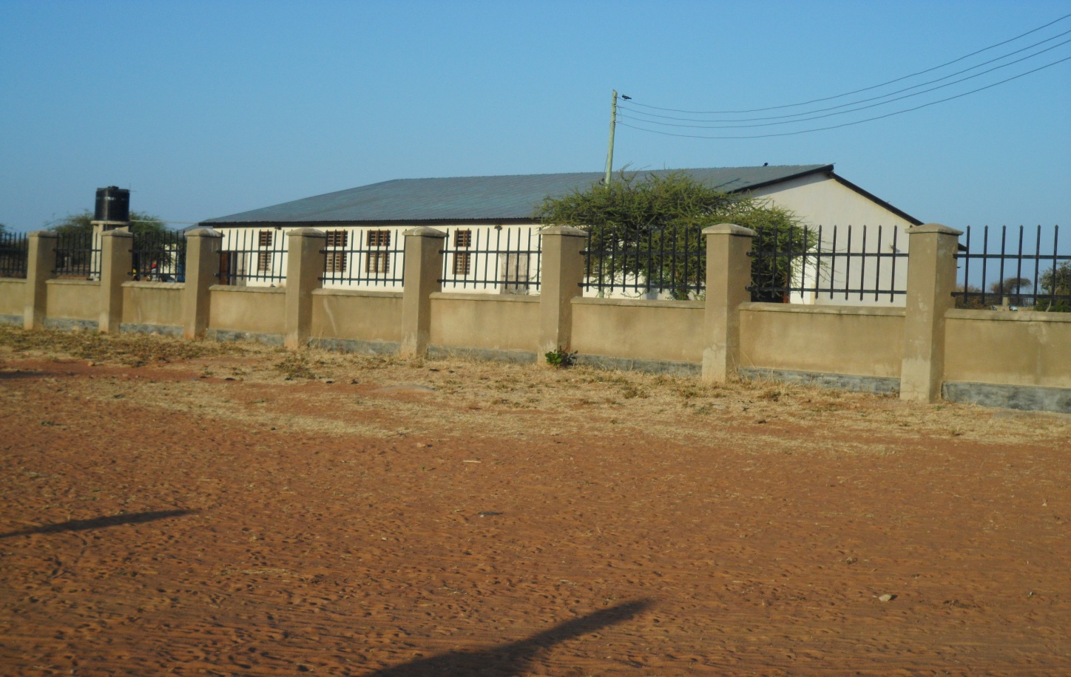

Figure 1.2: Ushirika Auction Mart in Nzega Town Council
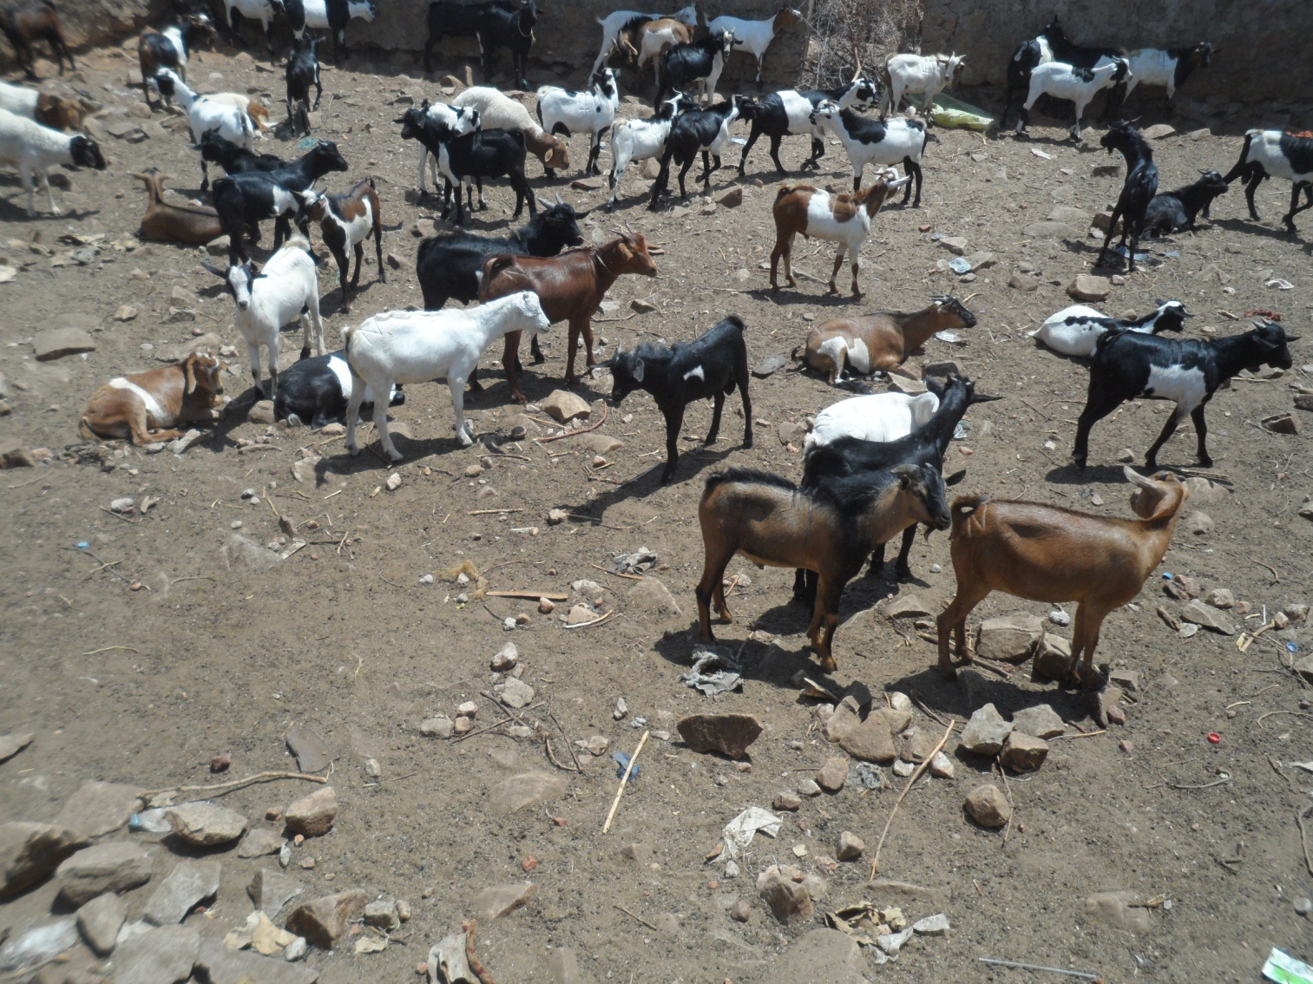
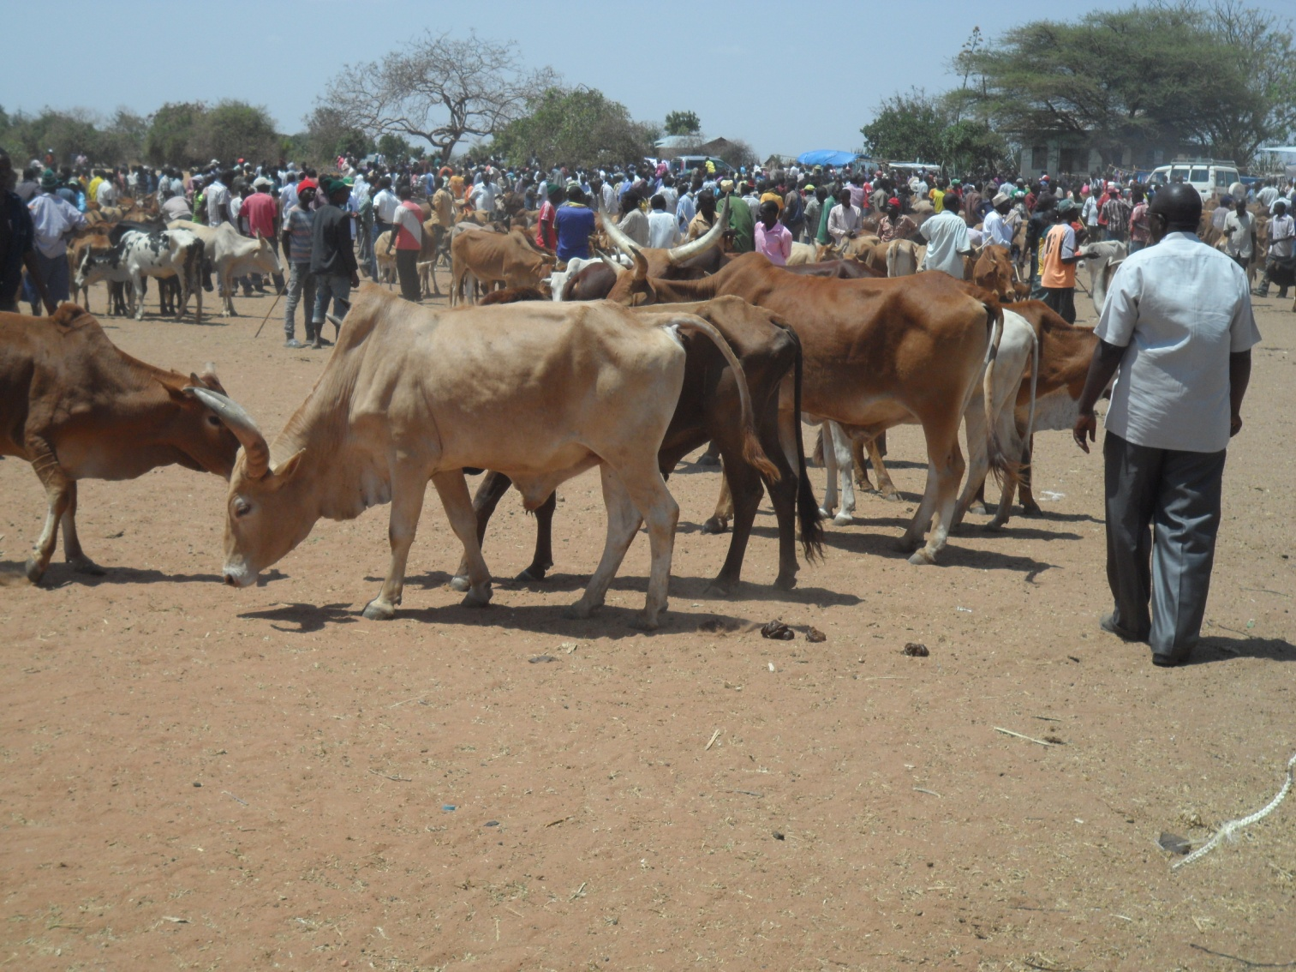

2.2.3 Marketing Livestock and Their Products
Nzega town council, though has large number of livestock has not successfully boost the economy of individual as well as the council. The main problem of its underperformance is due to lack of proper procedure of marketing livestock and their products. As a result, create a problem of getting reliable information of livestock and their products marketed and the amount of revenue collected from each type of livestock in the council.

2.2.4 Investment Opportunities in Livestock Subsector
Nzega Town council has inadequate livestock infrastructure that are working such as dips, veterinary centres, water points, abattoirs etc. Therefore, construction of livestock infrastructures might be a priority area for investing in livestock sub sector. Other areas which highly need investors are dairy farming and livestock processing industries such as milk processing, leather tanning and meat canning; specifically the region needs to look at the following possibilities:
- Meat processing: Nzega is strategically located in central, west and northern zones to house a modern meat processing plant. There is a need for building abattoirs in council which could process and add value and serve as a local market for livestock keepers.
- Tanneries: For adding value to the hides and skins by fully processing them or semi processed (wet blue) before export.
- Chicken – Meat processing industry
In Tanzania, Mwanza is very prominent in the production of traditional chicken. Chicken meat of this region is unique and has a palatable taste which attracts the market within and outside the region. Due to reliable source of chicken; the region is a good strategic area for investing in chicken-meat processing industry.
- Animal feeds:
Supplement feeds can be manufactured and sold to farmers. Fodder can also be planted and so is the selling of hay or seeds that can improve range land in the region.

- Livestock services and pharmaceuticals:
Establishment of livestock pharmaceutical shops and veterinary clinics where qualified veterinary and livestock officers can offer consultancy services especially in remote areas.
- Livestock Auctions markets: There is a need for improvement of available livestock markets by establishing all necessary facilities such as dips, slaughter slabs crushers, skin and hide shed as well as necessary offices and equipment related to the sector.

2.3 Natural Resources

2.3.1 Beekeeping
Production of honey and wax is another sector which has not been fully utilised by residents of Nzega Town council. Besides having conducive environment for modern bee keeping the council had limited number traditional beehives in Mbogwe,Miguwa,Ijanija, Itilo and Kitangili wards. There is a need for the council management to raise awareness of this opportunity for its residents in order to alleviate poverty for those living along these wards.
Beside tradition beehives, the council should also introduce the use of modern bee keeping practice to the residents of Nzega Town council due to the shortages of forests in all wards. One general observation from these data is that there is a high expectation on the improvement of bee keeping in future due to the availability of Miyombo type of trees and its environment.

2.3.2 Forest
Nzega town is one of the councils in Tabora region where only a small portion of their forest resources have been used to support the economy of the council. Among other reasons, the protection law of harvesting logs, wood and charcoal to a greater extent prohibit the selling of these products and make it difficult to get their information or data on the amount harvested. However, protection of forest to be harvested has resulted to illegal business of harvesting logs and production of charcoal in the council, though the use of charcoal and firewood has continued to be the main source of energy for cooking to all wards of Nzega Town council. The available data shows that the council earned about TShs. 10,000,000 from selling 50, 0000 bags of charcoal in 2015.

2.4 Mining
Mining though is an economic activity, so far is not well implemented in the council. Currently, there are lot of surveys and researches going on in search of existence of mineral deposits in terms of quantity and quality. These surveys and researches are done heavily by foreign companies while local companies are invested in small scales. However, there are small scale extractions of mineral at Nzega Ndogo mostly extracted mineral includes gold, quarrying and sand minerals. There was no data on distribution of existing mineral deposits in the council. These minerals are mostly purchased by brokers and dealers in Nzega town.

2.4.1 Investment Opportunities
- Mineral extraction
- Mining processing industries

2.5 Industries and Manufacturing
The economy of NTC is dominated by few industries performed by the residents as their source of income. The population and housing census confirm that Commercial agriculture, food crops and forestry is the main source of income in the Council, engaged 62.9 percent of Council residents. Others are domestic services (9.3 percent), Trade and Commerce (6.0 percent), Livestock and other related (4.2 percent), Mining and Quarrying (3.8 percent), Manufacturing (3.1 percent), raw food sales (2.6 percent, construction (2.5 percent) and services for food Hotel and Lodges (1.4 percent). Other industries performed in the Council at small scale include, haulage and storages, administration and security services, education services and other socio-economic industries accounted for 4.2 percent.
In order to promote industrial investment, NTC has cited an area where industries can be established. The cited area has a size of 295 Ha and is allocated for open space, Industrial area, institutions, hotels, business and auto garage.
Also there are areas favorable for investments which are found in Mwanzoli 75ha, Uchama 20Ha and Nzega Ndogo 200Ha wards.

2.5.1 Investment Opportunities
- Presence of industrial area of 295 hectors
- Honey processing industries
- Furniture industries
- Leather industries and related product (Turning and dressing of leather, luggage, hand bags, sandals, harness and foot ware)
- Oil refining industries (like sun flower & ground nuts oil)
- Food processing industries (like juice, milk, butter, flour, beef & cheese)
- Beverage industries ( Juice and water)

2.6 Economic Infrastructures
Economic infrastructure is vital to economic and social Development growth in Agriculture industries, Mining, Trade, Natural resources and social services as well as National defense, Administration and political integration all depend on efficient and smooth operation of communication, Transport and energy resources

2.6.1 Road and Road Transport
Nzega town council, like other urban councils in the country, is well endowed with road network with all classifications, including trunk road, regional road, district or urban roads and feeder roads. The roads that are maintained by the central government are classified as trunk or regional roads, while those that are maintained by the councils are called district or urban roads and feeder roads; the rest of the roads are called peripheral roads and are mostly maintained by Village/Mitaa communities.
Furthermore 23.5 percent of road network of Nzega town council classified as trunk roads, about 5.3 percent road network are regional roads while district roads and the feeder roads covers 12.6 percent and 58.6 percent of the network.
Roads like blood arteries in the body are very instrumental in stimulating social and economic development of any council. Thus, for a successful council economic management, the Local Authority and the Government in particular, needs to place more emphasis on roads improvement.

2.6.2 Telecommunication and Media Coverage
Road transport is the only type of transportation for people and goods within and outside boundaries of NTC. It is one of the key sub-sectors that are responsible for sustainable development and poverty reduction initiatives in the Council. The Council is served by Regional roads, District or Urban roads and feeder roads. Other transport facilities such as Airport, Marine network and railway services are not available in NTC.

NTC has reliable and accessible communication facilities due to its geographical location. There is land line as well as mobile telephone networks in NTC operated by TTCL, TIGO, VODACOM, Airtel and Hallotel. It is estimated that the coverage of these services is perfect and reliable allover councils’ boundaries.

2.6.3 Financial Institutions
Tanzania Postal Corporation is the only company which provides courier for mail, fax, and parcel deliveries in Nzega Town Council. There are also 4 banks (NMB, CRDB, NBC and Postal Bank) which provide commercial and other banking services. Noteworthy, all the said banks have embarked on an aggressive credit facility programme to customers especially employees in the formal sector and businessmen.

2.6.4 Investment Opportunities in Economic Infrastructures
- To install petrol stations
- To establish restaurant and conference halls
- To construct car parking
- Reproduction of recorded media
- Printing

2.7 Social Infrastructures

2.7.1 Education
Education service in Nzega Town Council is provided at primary, secondary levels and Vocational levels.
(a) Pre – primary school.
The District has 39 pre- primary schools with 2716 pupils, among these, 1294 are boys and 1422 are girls.
(b) Primary school
NTC has 32 primary schools with a total of 17,929 out of these 8,816 are boys and 9,113 are girls. The schools have 456 teachers. In general the requirement of Teachers in the Town is 511 and therefore there is a shortage of 55 teachers.

- Vocational Training
Vocational training in the Town is offered at the Nzega Folk Development College where there are currently 125 out of which 87 are male and 38 are female students.
- Secondary Schools
The Nzega Town Council has 11 Secondary Schools out of these 3 are owned and operated by private institutions and 8 are Government schools with a total of 4557 (Boys 2031 and Girls 2526) all schools are equipped with laboratories with enough chemicals and apparatus . However the Town Council has 123 teachers (Male are 75 & Female are 48) who are energetic, committed and experienced.

The current situation of Secondary education in Nzega Town Council is also fall below the national standards in terms of quantity and quality as follows:
- the Council has only 8 public secondary schools out of 10 wards, 4 wards had not yet established a secondary school in 2015;
- The Completion Rate reached 80.7 percent with more so on for girls (83.9 percent) than boys (76.9 percent) in 2015;
- Pass Rate of Form IV Examinations reached 74.2 percent, although majority got division IV in 2015; and
Transition Rate reached only 32.9 percent of those completed form IV in 2015.
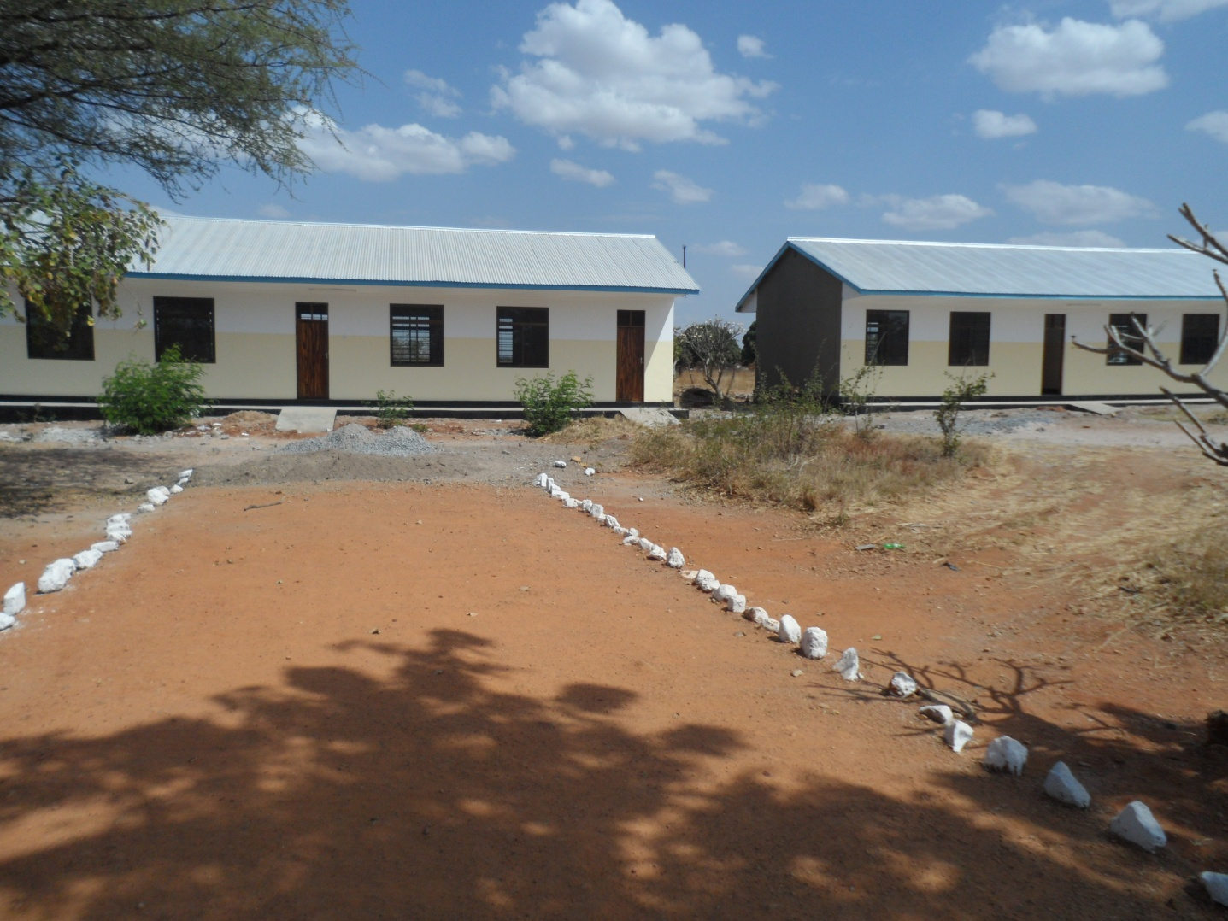

Figure 1.3: A photograph of some classes for advanced students in Bulunde Secondary school

2.7.2 Health
Health service in the District is provided at 1 District Hospital owned by Government, 1 health Center owned by Government and 1 owned by private and 5 dispensaries.
The current situation of Health Department in Nzega Town Council is still lagged behind the Health Policy Targets in terms of quantity and quality in both preventive and curative status.
Until 2018, NTC has managed to establish 2 health Centres and 5 dispensaries with an average of 3 wards per health centre and each dispensary serviced at most 12 Villages/Mitaa. NTC has also managed to reduce pressure on health facility from the average coverage of 22,276 people per facility or a less than a facility (0.4) per 10,000 people in 2002 to 7,987 people or 1.3 facilities per 10,000 people in 2012. However, NTC is still lagging behind in the implementation of health policy under which each ward has to have a health center and have a dispensary in each village.

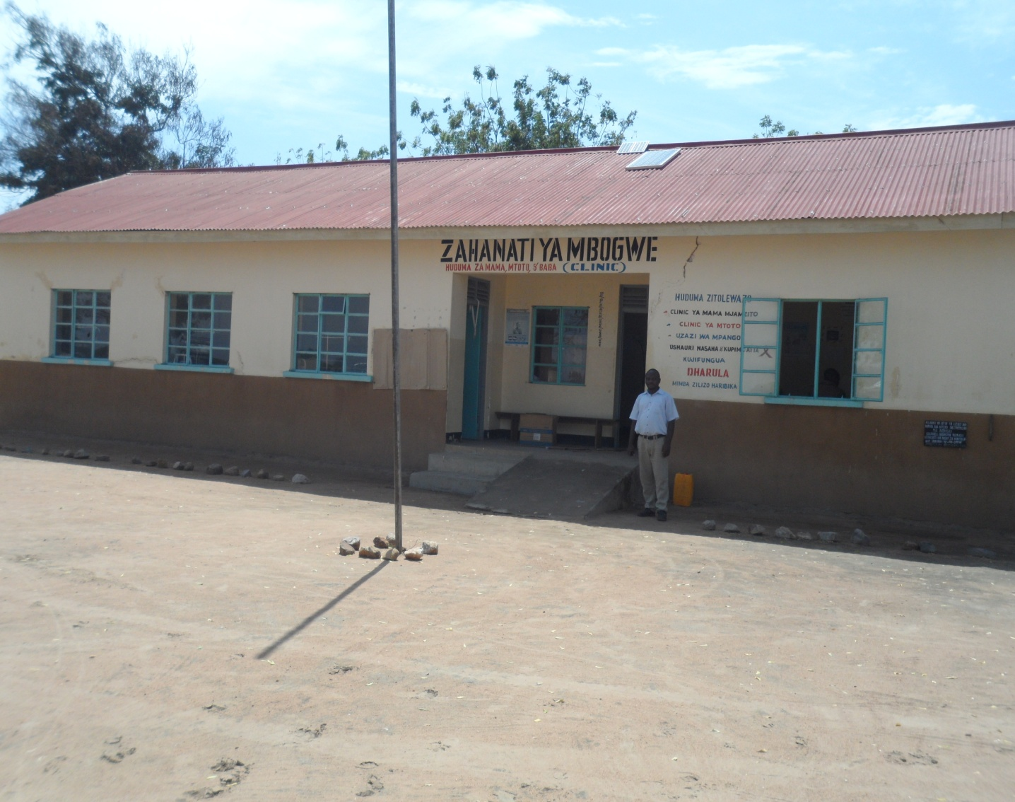Figure 1.4: A Photograph of Mbogwe dispensary.
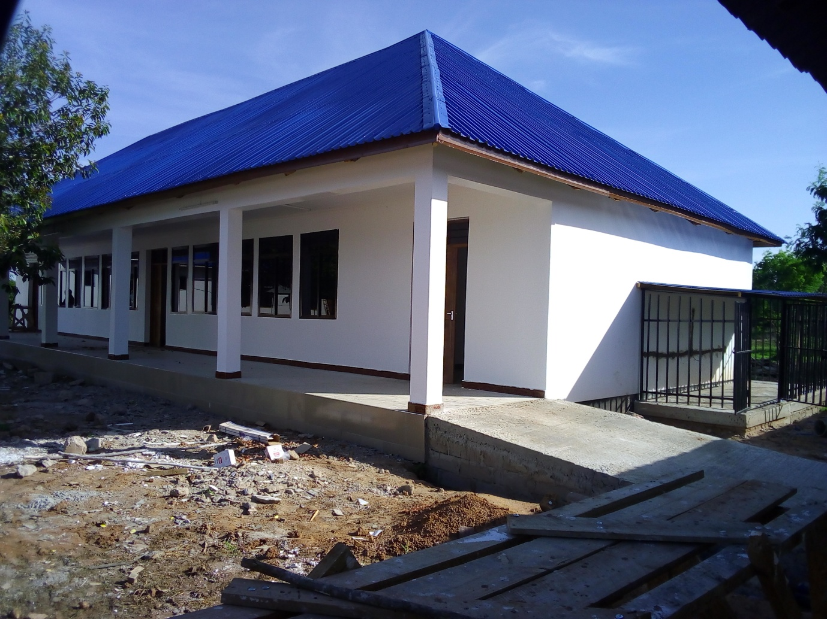

Figure 1.5: A Photograph of Operating theatre at Zogolo health centre
Tanzania Government in association with several stakeholders has continued to pursue improvements on availability along with the standards of health services. The health care continues to show some improvements in some areas, in particular by looking at health indicators. The achievements in health care were mostly due to some specific Government interventions. Besides the achievements made, there are still some areas that need further improvements, such as the number of health care facilities and skilled health care workforce.
For those who wish to invest or give a hand into the health care sector, there are numerous opportunities in Nzega Town Council, some specific investment areas involve:
• Providing resources to facilitate the construction and rehabilitation of health facilities at all levels
• Construction of Nzega Town Hospital
• Offering housing and other incentives for public health workers
• Providing training for health personnel (medical doctors, nurses and paramedical graduates, laboratory technicians)
• Offering health tools and equipment at all levels
• Establishing pharmaceuticals and offering drugs for curative and preventive measures
• Providing health information systems to facilitate efficient health planning and programs

2.7.3 Water Supply and Sanitations
Water service is still provided by both the urban water supply and rural water supply. Until 2015, only 42.8 percent of the households in Nzega Town Council had an access to safe and clean water leaving 57.2 percent of households used unsafe and clean water for drinking. Mainly Dams and Boreholes were the main source of safe and clean drinking water in the Council. Currently, the department has 5 Staff with a shortage of 5 Staff.
In Nzega Town Council has 2 dams (Kilimi and Uchama)

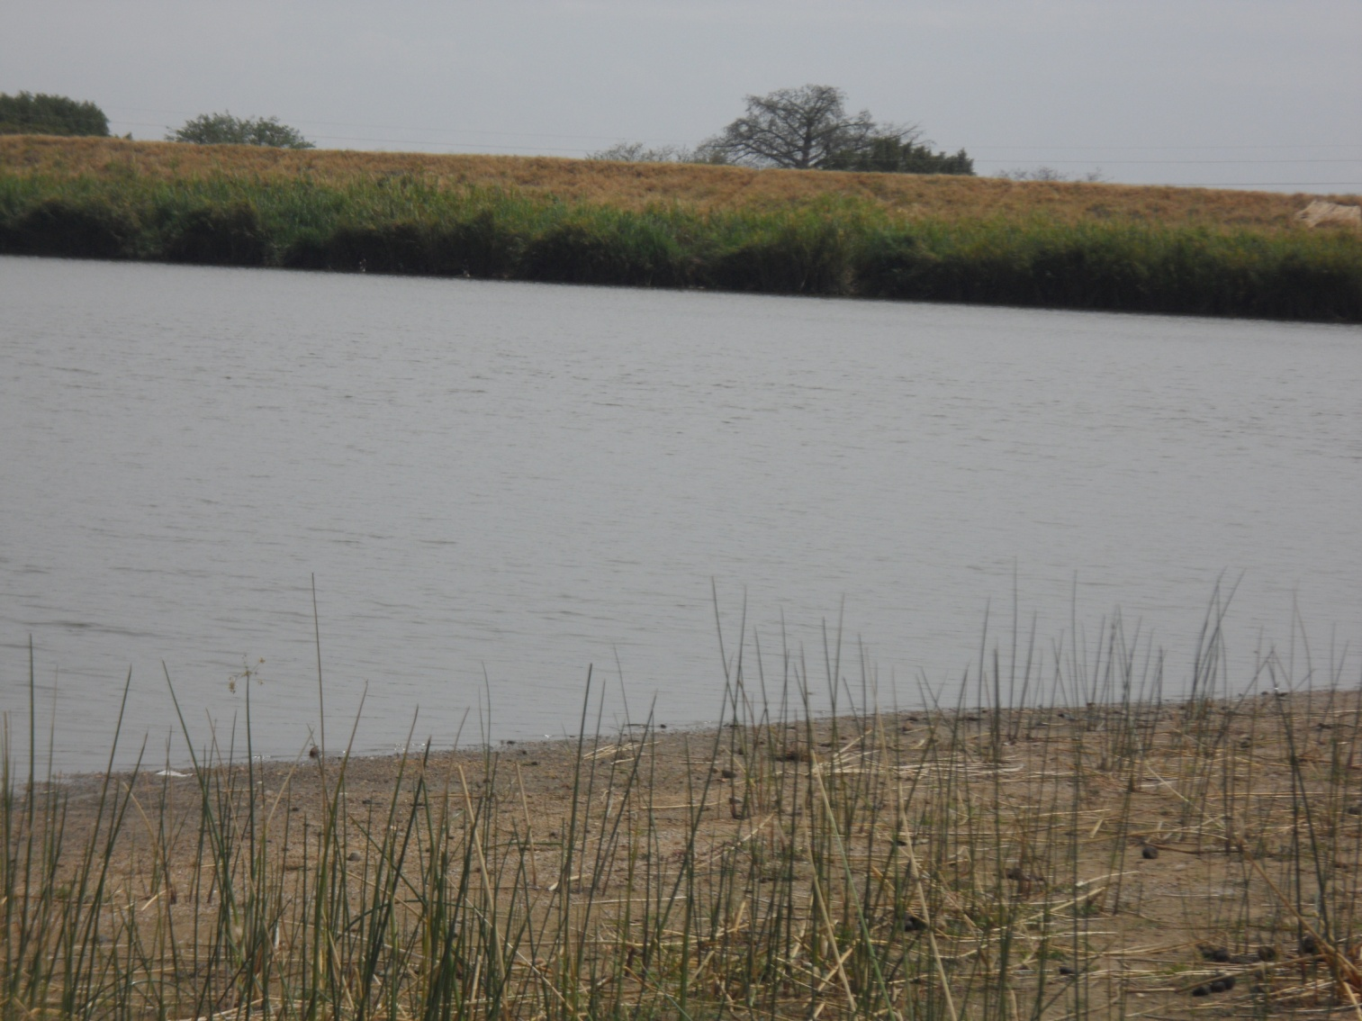

Figure 1.6: A Photograph of Kilimi dam in Nzega Town Council

2.7.4 Security Services
The main task of the district council is to provide social and economic services to the people, in order to achieve this goal successfully. It has to ensure that peace and tranquility prevails to the citizens as well as to the investors and shareholders. This is maintained through police, courts and the office of District Commissioner in collaboration with the Town Director

2.7.5 Investment Opportunities in Social Infrastructures
- To establish medium schools (Nursery, primary and secondary)
- To build colleges and university
- To build hospital and pharmacies
- Beverage industries ( Bottled water)

CHAPTER THREE

3.1 Investment Incentives
The Central Government and the Town Council are very eager to promote local and foreign investment to stimulate economic growth, reduce poverty and obtain more social and economic benefits, especially in the rural areas where most people live. These areas describe investment incentives that have been adopted, and there are policies, management procedures and a legal framework to facilitate investors and economic activities in Nzega Town Council.

3.2 Access to Land
Potential Investors passing through IPA will be assured priority access to land set aside by the government for allocation to investors. The investor is entitled to apply to the government for a lease of land outside registered villages.

3.3 Expatriate employment
Investors are assured the right to employ expatriate personnel required for enterprises development and for the use of technology and skills that are not available locally particularly if such personnel will facilitate the adoption and acquisition of skills by local personnel. IPA will ensure that investors have the final say on what they desire and the engagement of expatriate personnel without any condition.

3.4 Business license
It takes one day to get the business license after filling the application forms. The business license issued once (Non-renewable) at the beginning of such business and shall remain valid until the business is closed or run bankruptcy. At the Town Council there is trade unit under Finance and Trade department which is responsible mainly for facilitation of business licensing and also on giving clarification of policies and laws related to business operations. Business license is the final document required commencing business operations.

3.5 Why Investing at Nzega?
Nzega Town Council is part of the vicinity that feeds the major urban center of Igunga, Tabora, Shinyanga, and Singida. Its location, the availability of diverse natural resources, good infrastructure (both social and economic), hospitality of the people, amiable weather, plentiful labour (both skilled and semi-skilled) and water supplies makes it ideal areas for investments in agriculture, livestock, mining, tourism and business. The Council is committed to attract and support investments by foreign and local investors and has identified several types and areas for investment in the Council. It adheres to the national programs, incentives and procedures to attract, facilitate and manage investments and has also adopted some local incentives to complement them, especially in the allocation of land, access to infrastructure and information. It is also committed to improving the infrastructure and the development of education services to support investments in economic activities. Thus, investors from within Tanzania and all over the world are warmly welcomed and encouraged to Invest in Nzega Town Council.

Important Contact Address
Godfrey Ngupula,
District Commissioner,
P.O. Box 1,
NZEGA.

Philemon M.Magesa
Town Director,
P.O. Box 256,
NZEGA
0677003373
Email: td@nzegatc.go.tz

Appendix.1





